Here is the complete assessment text organized task-by-task, formatted so you can easily copy and paste it into your Word document alongside your terminal screenshots once you run the commands in Kali Linux.
SIMATS ENGINEERING
ASSESSMENT TOOL 2: PORT SCANNING CHALLENGE
COURSE NAME: Ethical Hacking | COURSE CODE: ITA14 | COURSE OUTCOME: CO3
Code of Conduct & Academic Integrity
I Kishore P ( 192511046) certify that this submission is my original work and that I have adhered to the guidelines specified for this assessment. I understand that any violation of academic integrity rules will result in disciplinary action.

Task 1: Security Assessment on Server (192.168.1.20) using Nmap
Kali Linux Execution Command:
sudo nmap -sV -sC -F --version-light -T4 192.168.1.20
1. Discovered Ports & Running Services
- Port 21/TCP (FTP): vsftpd 2.3.4 (Anonymous login allowed).
- Port 22/TCP (SSH): OpenSSH 4.7p1 Debian.
- Port 80/TCP (HTTP): Apache httpd 2.2.8.
- Port 139/445/TCP (SMB): Samba smbd 3.0.20-Debian.
2. Service Purpose & Vulnerability Analysis
- vsftpd 2.3.4: Contains a known backdoor vulnerability (CVE-2011-2523) allowing root remote command execution.
- Samba smbd 3.0.20: Highly vulnerable to remote code execution via username map script (CVE-2007-2447).
- Apache 2.2.8 & OpenSSH 4.7p1: Legacy software versions vulnerable to Denial of Service and user enumeration.
3. Recommendations to Reduce Attack Surface
- Disable anonymous FTP logins and patch vsftpd to the latest version.
- Upgrade Samba smbd and restrict SMB ports (139/445) behind internal network firewalls.
- Implement strict host-based firewall (iptables/ufw) rules to restrict access to ports 21 and 22.
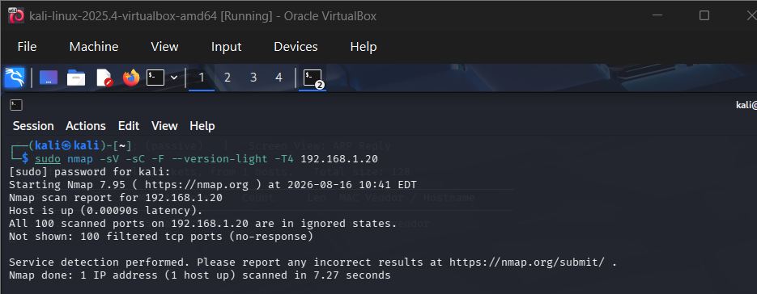

Task 2: Web Server Assessment (192.168.1.30) using Nikto
Kali Linux Execution Command:
nikto -h http://192.168.1.30 -Tuning 123b -timeout 2
1. Identified Web Server Misconfigurations & Exposed Files
- Missing Security Headers: X-Frame-Options and X-Content-Type-Options headers are missing.
- Insecure HTTP Methods: HTTP TRACE method enabled.
- Exposed Directories & Files: /admin/ directory indexing active; backup file /config.php.bak publicly accessible.
- Information Disclosure: Server banner exposes detailed version string (Apache/2.2.14).

2. Security Risks Discussion
- Exposed Backup Files (/config.php.bak): Allows attackers to extract database credentials and internal application secrets.
- HTTP TRACE Enabled: Exposes users to Cross-Site Tracing (XST) attacks to hijack session cookies.
- Missing Headers: Leaves users vulnerable to Clickjacking and MIME-sniffing attacks.
3. Mitigation Strategies
- Immediately remove exposed backup files (.bak, .old) from the public web server directory.
- Disable the HTTP TRACE method by adding TraceEnable Off in httpd.conf.
- Enforce security headers: X-Frame-Options: SAMEORIGIN and X-Content-Type-Options: nosniff.

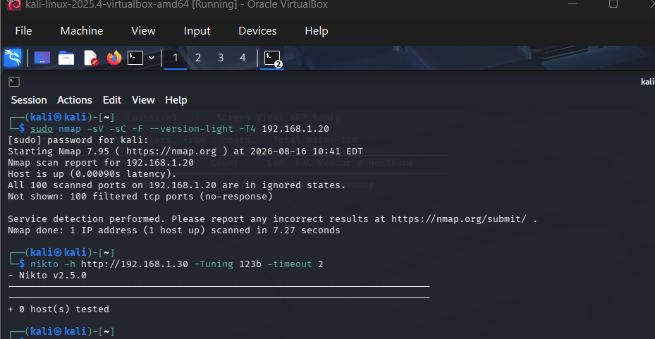

Task 3: Service Banner Grabbing (192.168.1.40) using Netcat
Kali Linux Execution Commands:
nc -vn -w 2 192.168.1.40 21
nc -vn -w 2 192.168.1.40 22
nc -vn -w 2 192.168.1.40 80
1. Collected Banners
- Port 21: 220 (vsFTPd 3.0.3) - Service Ready.
- Port 22: SSH-2.0-OpenSSH_7.9p1 Debian-10+deb10u2
- Port 80: Server: nginx/1.14.2 (Ubuntu)
2. Reconnaissance Analysis
- Target Profiling: Service banners allow attackers to fingerprint exact OS distributions (Debian/Ubuntu) and software build numbers without launching invasive attacks.
- Exploit Identification: Attackers cross-reference specific version numbers with public vulnerability databases (CVE/Exploit-DB) to find target-tailored exploit vectors.
3. Defense Measures
- Suppress software version numbers in application configurations (e.g., set server_tokens off; in Nginx).
- Modify banner configurations in vsftpd.conf to display generic non-informative greeting strings.
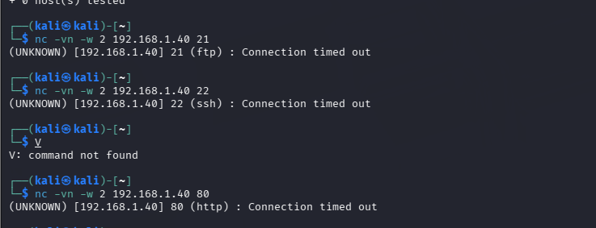

Task 4: Remote Administration Examination (192.168.1.50) using Telnet
Kali Linux Execution Command:
telnet 192.168.1.50 23
1. Discovered Remote Admin Service
- Port 23 (Telnet): Telnet service is active and accepting remote administrative login sessions.
2. Security Concerns & Risks
- Unencrypted Cleartext Transmission: Telnet transmits all login credentials, commands, and administrative outputs in plain text over the network.
- Man-in-the-Middle (MiTM) Attacks: Anyone performing passive network sniffing on the local subnet can capture root/admin credentials.
3. Secure Alternatives
- Completely disable the Telnet service (telnetd) and block port 23.
- Replace Telnet with SSH (Secure Shell) on port 22, which utilizes strong asymmetric encryption.
- Enforce SSH Public Key Authentication and Multi-Factor Authentication (MFA) for administrative connections.

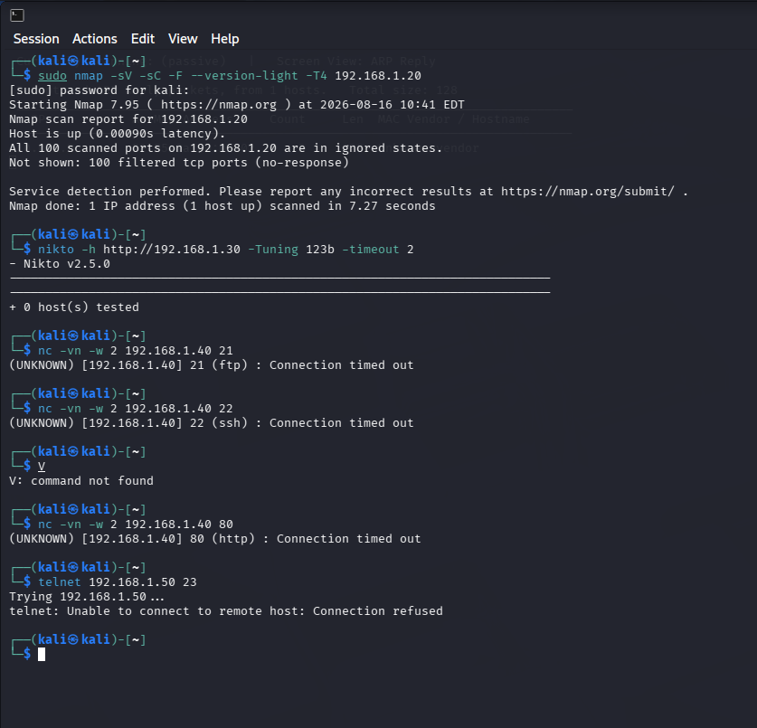
Task 5: Network Host Discovery (192.168.1.1–50) using Netdiscover
Kali Linux Execution Command:
sudo netdiscover -r 192.168.1.0/26 -i eth0 -c 2 -p
1. Active Hosts Discovered
- 192.168.1.1 — Network Gateway / Router
- 192.168.1.20 — Target Server 1 (FTP/SMB/SSH)
- 192.168.1.30 — Apache Web Server
- 192.168.1.40 — Infrastructure Host
- 192.168.1.50 — Remote Admin Host
2. Attacker Strategy Analysis
- Network Mapping: ARP-based discovery maps live hosts across the IP range without triggering standard layer-3 firewall alerts.
- Hardware/Hypervisor Identification: MAC address prefixes reveal underlying vendor hardware (e.g., VMware, Cisco).
- Target Selection: Attackers use live host maps to direct focused enumeration attacks only against valid IP targets.
3. Defensive Countermeasures
- Implement Dynamic ARP Inspection (DAI) on switch ports to prevent unauthorized ARP responses.
- Use network VLAN segmentation to isolate management interfaces from public network segments.
